**Installing Kubernetes on Ubuntu 20.04 running on AWS EC2 Instances and deploying an Nginx server on Kubernetes.**

In this tutorial, I will guide you through installing Kubernetes on Ubuntu instances on AWS and then demonstrate how to deploy a simple Nginx server on Kubernetes.

In order to do this, we will spin up two Ubuntu instances from the AWS Console. One of them will be configured as the Master node, while the other will be the worker node.

When configuring the instances, we should choose at least `2 CPU Core` and `2GB RAM` at minimum to get the system working efficiently. In terms of instance type,`t2.medium` does the job so we will use it to satisfy the minimum infrastructure requirement.

**Part 1 Configuring Security Groups**

Before spinning up the instances, we must configure two security groups to go with the instances. The Kubernetes documentation requires specific ports to be open for the Kubernetes to run smoothly. You can check the documentation from [here](https://kubernetes.io/docs/reference/ports-and-protocols/).

***Ports for the Control-plane (Master) Node(s)***

1. TCP 6443 → For Kubernetes API server

2. TCP 2379–2380 → For etcd server client API

3. TCP 10250 → For Kubelet API

4. TCP 10259 → For kube-scheduler

5. TCP 10257 → For kube-controller-manager

6. TCP 22 → For remote access with ssh

7. UDP 8472 → Cluster-Wide Network Comm. — Flannel VXLAN

***Ports for the Worker Node(s)***

1. TCP 10250 → For Kubelet API

2. TCP 30000–32767 → NodePort Services

3. TCP 22 → For remote access with ssh

4. UDP 8472 → Cluster-Wide Network Comm. — Flannel VXLAN

***Create Security Group for Master***

**1.** Go to the AWS Console, EC2 Service and choose Security Group from the left hand bar menu.

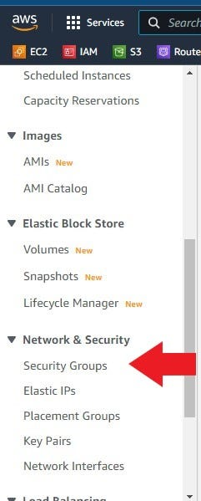

Security Group

**2.**Click on create security group, name it `K8-Master-SG`and then click on `add inbound rule` to enter the ports described above. When you are done just click on create security group on the lower left of the page to finish the process.

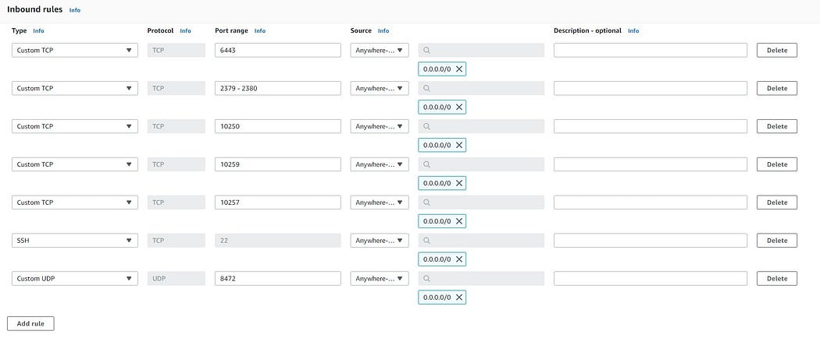

**3.**Choose Security Group from the left hand bar menu one more time for the worker security group.

**4.** Click on create security group, name it `K8-Worker-SG`and then click on `add inbound rule` to enter the ports described above. When you are done just click on create security group on the lower left of the page to finish the process.

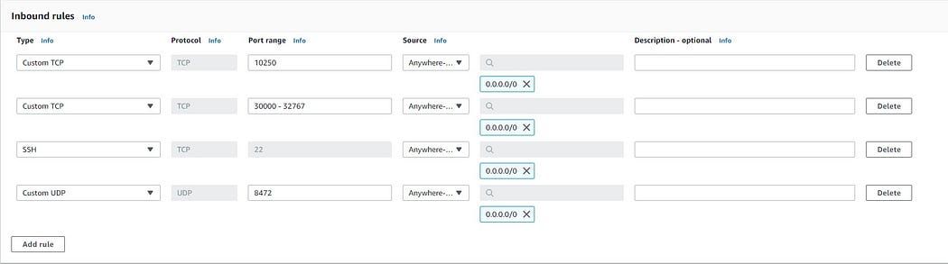

**Part 2 Creating instances**

**1.** Go to the AWS Console, EC2 Service and hit on `Launch instance`.

**2.** Name your instance `kube-master` and choose Ubuntu 20.4 as AMI.

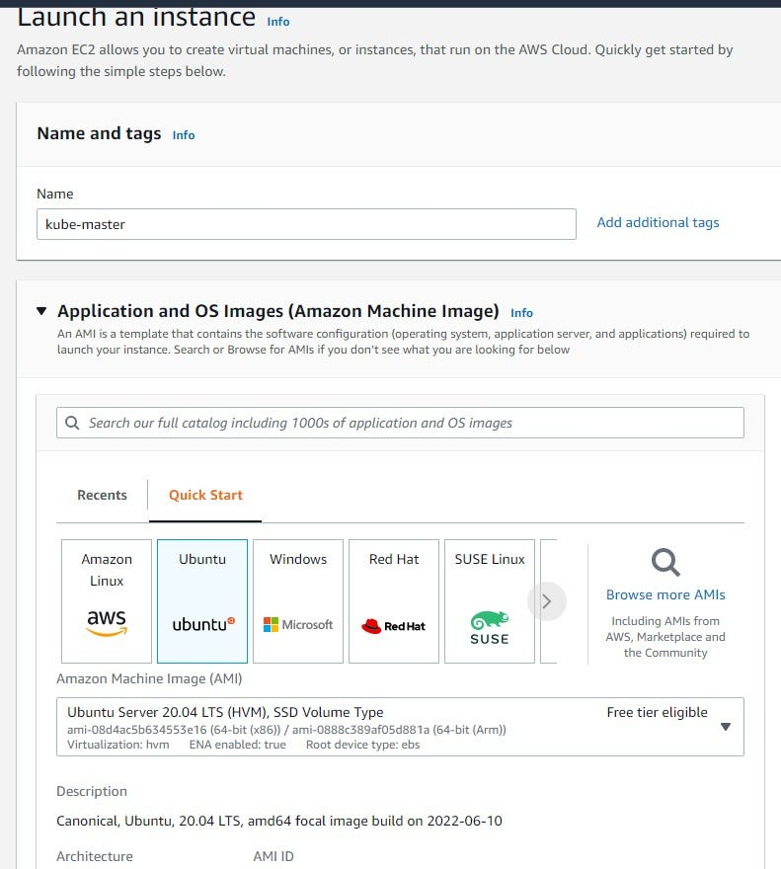

**3.** Choose `t2.medium`as instance type, choose your own key, select existing security groups and choose the master security group that we just created and finally hit on `launch instance`.

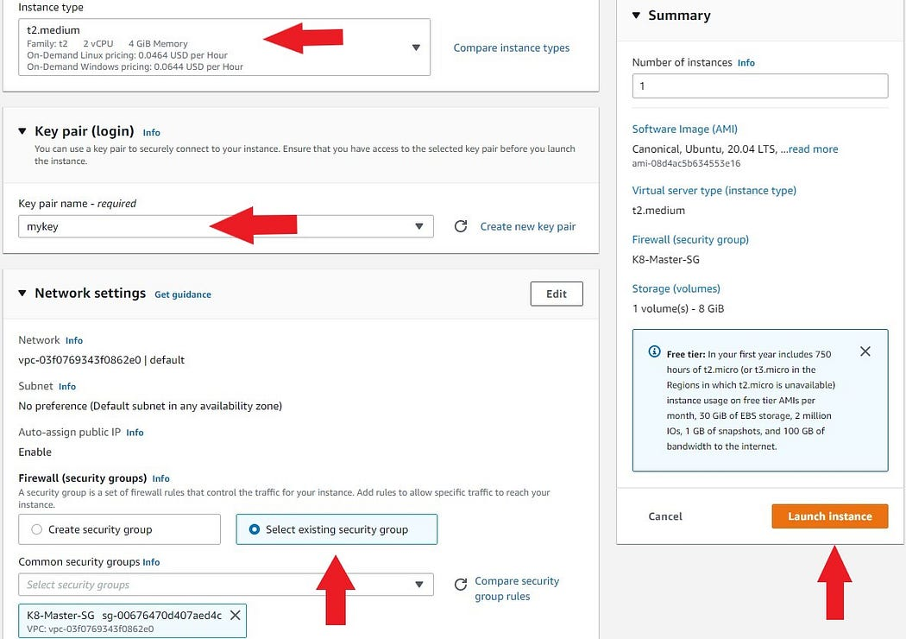

launch instance

**4.** Repeat the steps above to create the worker instance. Keep the same configuration and just name it `kube-worker-1`and choose the `K8-Worker-SG` security group.

**5.** Wait for the instances to boot up. Then ssh into both of them.

ssh -i “yourkey.pem” ubuntu@xxx.xxx.xx.xx ## (Replace x with your instance’s public IP address)

**Part 3 Working with instances**

**1.** First of all, we should change the hostnames of the instances so that we should know which one is master and which one is the worker. let’s start with the master node.

sudo hostnamectl set-hostname master

**2.** Then write `bash`and hit enter to see the new hostname.

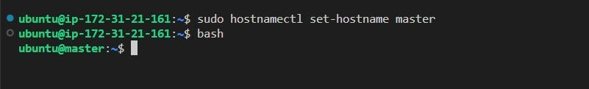

**3.** Before installing Kubernetes packages, we should update the system.

sudo apt-get update

**4.**Now, we can install helper packages for Kubernetes.

sudo apt-get install -y apt-transport-https gnupg2

**5.** Continue installing the helper packages

curl -s <https://packages.cloud.google.com/apt/doc/apt-key.gpg> | sudo apt-key add -echo “deb <https://apt.kubernetes.io/> kubernetes-xenial main” | sudo tee -a /etc/apt/sources.list.d/kubernetes.list

**6.** We need to update the system again after we are done with the helper packages.

sudo apt-get update

7. Continue with the Kubernetes installation including Docker

sudo apt-get install -y kubectl kubeadm kubelet kubernetes-cni docker.io

**8**. Now we have to start and enable Docker service.

sudo systemctl start dockersudo systemctl enable docker

**9.** For the Docker group to work smoothly without using sudo command, we should add the current user to the `Docker group`.

sudo usermod -aG docker $USER

**10.** Now we run the following command so that the changes take affect immediately.

newgrp docker

**11.**As a requirement, update the `iptables` of Linux Nodes to enable them to see bridged traffic correctly. Thus, you should ensure `net.bridge.bridge-nf-call-iptables` is set to `1` in your `sysctl` config and activate `iptables` immediately.

cat << EOF | sudo tee /etc/sysctl.d/k8s.confnet.bridge.bridge-nf-call-ip6tables = 1net.bridge.bridge-nf-call-iptables = 1EOFsudo sysctl --system

We are done with the initial configuration of the master node. Now we will repeat all 10 steps for the worker node. The only difference would be the name of the node.

**1.** Change the terminal to the worker node instance and change the host name

sudo hostnamectl set-hostname worker

**2.**Then write `bash`and hit enter to see the new hostname.

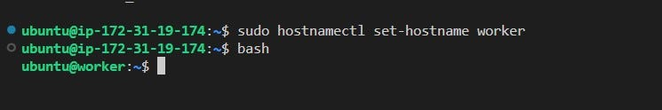

**3**. Before installing Kubernetes packages, we should update the system.

sudo apt-get update

**4.** Now, we can install helper packages for Kubernetes.

sudo apt-get install -y apt-transport-https gnupg2

**5.** Continue installing the helper packages

curl -s <https://packages.cloud.google.com/apt/doc/apt-key.gpg> | sudo apt-key add -echo “deb <https://apt.kubernetes.io/> kubernetes-xenial main” | sudo tee -a /etc/apt/sources.list.d/kubernetes.list

**6.** We need to update the system again after we are done with the helper packages.

sudo apt-get update

**7.** Continue with the Kubernetes installation including Docker

sudo apt-get install -y kubectl kubeadm kubelet kubernetes-cni docker.io

**8.** Now we have to start and enable Docker service.

sudo systemctl start dockersudo systemctl enable docker

**9.**For the Docker group to work smoothly without using sudo command, we should add the current user to the `Docker group`.

sudo usermod -aG docker $USER

**10.** Now we run the following command so that the changes take affect immediately.

newgrp docker

**11.** As a requirement, update the `iptables` of Linux Nodes to enable them to see bridged traffic correctly. Thus, you should ensure `net.bridge.bridge-nf-call-iptables` is set to `1` in your `sysctl` config and activate `iptables` immediately.

cat << EOF | sudo tee /etc/sysctl.d/k8s.confnet.bridge.bridge-nf-call-ip6tables = 1net.bridge.bridge-nf-call-iptables = 1EOFsudo sysctl — system

**Part 4 — Setting Up Master Node for Kubernetes**

In this part, we will execute commands of on Master Node only.

**1.**We will pull the packages for Kubernetes beforehand

sudo kubeadm config images pull

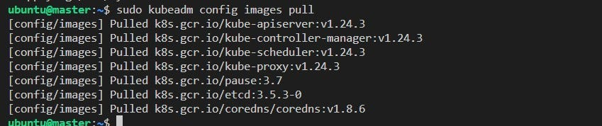

images

**2**. By default, the Kubernetes cgroup driver is set to system, but docker is set to systemd. We need to change the Docker cgroup driver by creating a configuration file `/etc/docker/daemon.json` and adding the following line then restart deamon, docker and kubelet:

echo ‘{“exec-opts”: [“native.cgroupdriver=systemd”]}’ | sudo tee /etc/docker/daemon.jsonsudo systemctl daemon-reloadsudo systemctl restart dockersudo systemctl restart kubelet

**3**. At this stage, the `kubeadm` will prepare the environment for us. For this we need the private IP of the master node.

sudo kubeadm init — apiserver-advertise-address=172.31.21.161 — pod-network-cidr=10.244.0.0/16 # Use your master node’s private IP

**4.** If you did everything correctly, you should see the following screen.

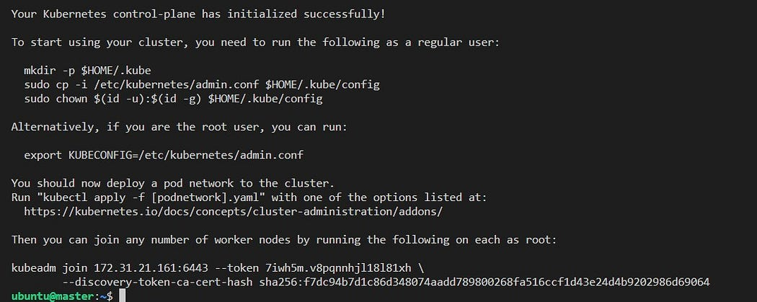

**5.** At this point note down the last part of the output that includes the `kubeadm join `:



join

**6.** Now, we need to run the following commands to set up local `kubeconfig` on master node.

mkdir -p $HOME/.kubesudo cp -i /etc/kubernetes/admin.conf $HOME/.kube/configsudo chown $(id -u):$(id -g) $HOME/.kube/config

**7.**Activate the `Flannel` pod networking.

kubectl apply -f <https://github.com/coreos/flannel/raw/master/Documentation/kube-flannel.yml>

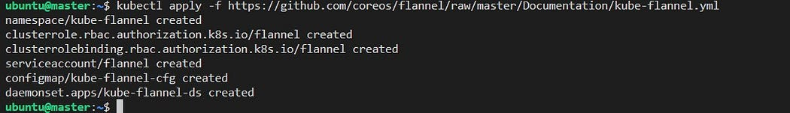

flannel

**8.** Finally check to see that the Master node is ready

kubectl get nodes

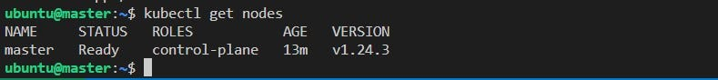

kubectl

**Part 5 — Adding the Worker Node to the Cluster**

In the previous part, we configured the master node. Therefore, when we ran the `kubectl get nodes `command, we could only see the master nod as ready.In this part, we will add the worker node to the cluster.

**1.** By default, the Kubernetes cgroup driver is set to system, but docker is set to systemd. We need to change the Docker cgroup driver by creating a configuration file `/etc/docker/daemon.json` and adding the following line then restart deamon, docker and kubelet:

**2.** Ensure that you run the following commands on the worker node.

echo ‘{“exec-opts”: [“native.cgroupdriver=systemd”]}’ | sudo tee /etc/docker/daemon.jsonsudo systemctl daemon-reloadsudo systemctl restart dockersudo systemctl restart kubelet

**3.** Remember that we noted `sudo kubeadm join…` command previously. We will now run that command to have them join the cluster. Do not forget to add `sudo` before the command.

sudo kubeadm join 172.31.21.161:6443 — token 7iwh5m.v8pqnnhjl18l81xh — discovery-token-ca-cert-hash sha256:f7dc94b7d1c86d348074aadd789800268fa516ccf1d43e24d4b9202986d69064

Congratulations, we are all set.

Now let’s go to the master node and get the list of nodes. If we did everything correctly, then we should see the new worker node in the list.

kubectl get nodes

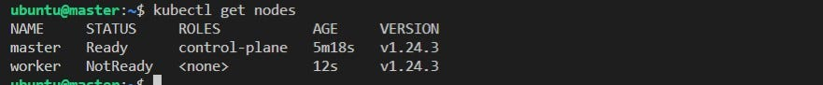

We can also get a detailed version of the nodes.

kubectl get nodes -o wide

**Part 6 — Deploying a Simple Nginx Server on Kubernetes**

We have created our Kubernetes cluster with two nodes. Now, we will deploy a simple Nginex server and check that it works.

**1.** Let’s create and run a simple `Nginx` Server image.

kubectl run nginx-server — image=nginx — port=80

We should get a `pod/nginx-server created`message as output.

2. Let’s check the list of pods to see that Nginx is added to the list.

kubectl get pods -o wide

**3.** Expose the nginx-server pod as a new Kubernetes service on master.

kubectl expose pod nginx-server — port=80 — type=NodePort

We should get a `service/nginx-server exposed` message as output.

**4.** Get the list of services and show the newly created service of `nginx-server`

kubectl get service -o wide



kubectl get service

**5.**From the output, we clearly see that the Nginx server can be reached from the 80:32682 port. (Your port number will be different so check yours)

**6.** Now, let’s check whether we correctly deployed Nginx. So open a browser of your choice. Enter the public IP address of your worker instance followed by a `:` and the Nodeport number which in my case is 32682.

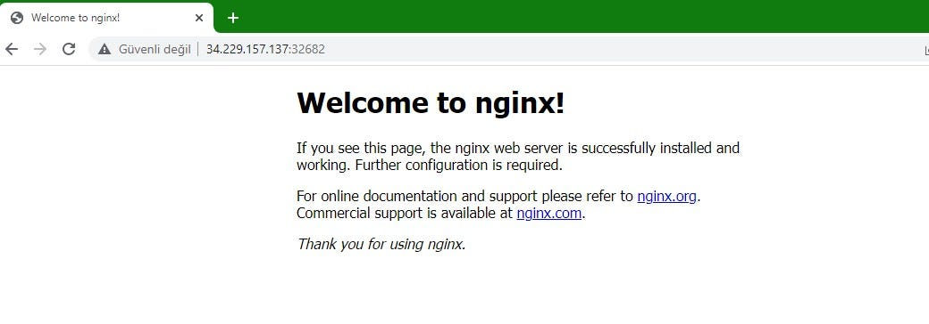

nginx

Congratulations! We have correctly started Nginx!

**Part 7 Clean Up**

**1.** Let’s start cleaning up with the Nginx

kubectl delete service nginx-serverkubectl delete pods nginx-server

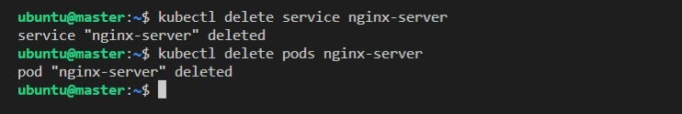

**2.** Let’s delete the worker node by entering the following commands on the Master node. But first we need to check the name of the worker node by entering the `kubectl get nodes`command.

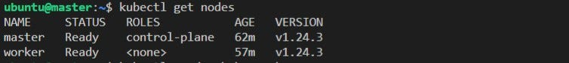

As you can see my worker node is named `worker`. So I will use `worker`in the following commands.

kubectl cordon workerkubectl drain worker — ignore-daemonsets — delete-emptydir-datakubectl delete node worker

**3.** Now let’s go to the worker node and reset it. Note that you will have to confirm with a `y`.

sudo kubeadm reset

**4.** Normally, we did not have to do the first three commands because we are going to terminate the instances and everything will be gone. However, I did so to see how we can delete servcies and reset nodes if were to keep the instances.

**5.** Now, go to the AWS console and terminate both the master and the worker instances.

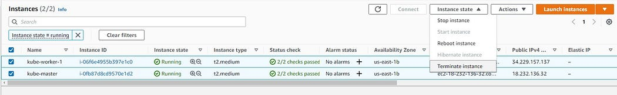

terminate ec2 instances